Etymological Dictionary

What is Etymological Dictionary
# Source: AI Source: Provided by: [Data Path: Persons Table -> ID Column: 1, Name_En Column: Motasem Essam] -> From: [Chatgpt (GPT-4-turbo)] on [7/29/2025]
An Etymological Dictionary provides detailed information about the origin, history, and evolution of words. It traces how a word has developed over time, including its roots in older languages, sound changes, and shifts in meaning.

🔹 Key Features of an Etymological Dictionary
# Source: AI Source: Provided by: [Data Path: Persons Table -> ID Column: 1, Name_En Column: Motasem Essam] -> From: [Chatgpt (GPT-4-turbo)] on [7/29/2025]
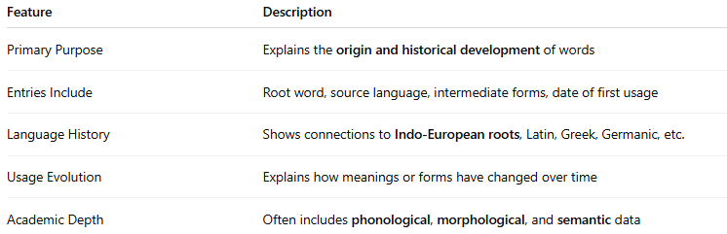
Feature | Description
Primary Purpose | Explains the origin and historical development of words
Entries Include | Root word, source language, intermediate forms, date of first usage
Language History | Shows connections to Indo-European roots, Latin, Greek, Germanic, etc.
Usage Evolution | Explains how meanings or forms have changed over time
Academic Depth | Often includes phonological, morphological, and semantic data

🔹 Examples of Etymological Dictionaries
# Source: AI Source: Provided by: [Data Path: Persons Table -> ID Column: 1, Name_En Column: Motasem Essam] -> From: [Chatgpt (GPT-4-turbo)] on [7/29/2025]
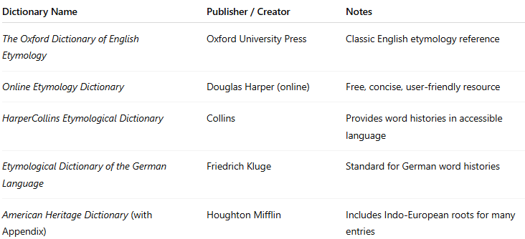
Dictionary Name | Publisher / Creator | Notes
The Oxford Dictionary of English Etymology | Oxford University Press | Classic English etymology reference
Online Etymology Dictionary | Douglas Harper (online) | Free, concise, user-friendly resource
HarperCollins Etymological Dictionary | Collins | Provides word histories in accessible language
Etymological Dictionary of the German Language | Friedrich Kluge | Standard for German word histories
American Heritage Dictionary (with Appendix) | Houghton Mifflin | Includes Indo-European roots for many entries

🔹 Advantages
# Source: AI Source: Provided by: [Data Path: Persons Table -> ID Column: 1, Name_En Column: Motasem Essam] -> From: [Chatgpt (GPT-4-turbo)] on [7/29/2025]
- Deepens understanding of word origins and structure
- Reveals connections between languages
- Enhances knowledge of historical linguistics
- Aids in decoding unfamiliar vocabulary (esp. for students and linguists)

🔹 Use Cases
# Source: AI Source: Provided by: [Data Path: Persons Table -> ID Column: 1, Name_En Column: Motasem Essam] -> From: [Chatgpt (GPT-4-turbo)] on [7/29/2025]
- Historical and comparative linguistics
- Lexicography and philology
- Language education and research
- Writers and poets exploring the richness of word origins

